Department of Medicine
Rangpur Medical College Hospital
December-2021

Duty roster of Registrars /Asstt. Registrars/IMOs/HMOs/MD students in Medicine Department
Date | Day | Morning | Evening | Night
01.12.21 | Wednesday | All | Dr. Tahmina | Dr. Sajib Kumar Sarkar
02.12.21 | Thursday | All | Dr. Ahsanul Haque (Hasan) | Dr. Shaun
03.12.21 | Friday-VI | Dr. Jerin Tasnim | Dr. Asima | Dr. Jahidul Alam
04.12.21 | Saturday | All | Dr. Farzana Haque | Dr. Masrurul Haque
05.12.21 | Sunday | All | Dr. Mohsina Akhtar | Dr. Hasan Mahmud Asif
06.12.21 | Monday | All | Dr. Nasima Akhter Muna | Dr. Kamal Hossain
07.12.21 | Tuesday | All | Dr. Md. Abdullah Al Mamoon | Dr. Tarik Jamil Apu
08.12.21 | Wednesday | All | Dr. Abdul Alim Sarker | Dr. Ahsan Ali Sarker
09.12.21 | Thursday | All | Dr. Biplob Chandra Sarker | Dr. Rokon
10.12.21 | Friday-I | Dr. Jerin Tasnim | Dr. Masrurul Haque | Dr. Shaun
11.12.21 | Saturday | All | Dr. Mostafizur Rahman | Dr. Shovendo Shekhar
12.12.21 | Sunday | All | Dr. Nazmul Karim | Dr. Jahidul Alam
13.12.21 | Monday | All | Dr. Fatema Sabrina | Dr. Saifur Rahman Selim
14.12.21 | Tuesday | All | Dr. Mammun ER Rashid | Dr. Mahmudul Hassan
15.12.21 | Wednesday | All | Dr. Maruf | Dr. Ahsan Ali Sarker
16.12.21 | Thursday | Dr. Asima | Dr. Firoz Mondol | Dr. Biplob Chandra Sarker
17.12.21 | Friday-II | Dr. Jafrin | Dr. Naznin | Dr. Hasan Mahmud Asif
18.12.21 | Saturday | All | Dr. Rukhsana Hossain | Dr. Mostafizur Rahman
19.12.21 | Sunday | All | Dr. Mohsina Akhtar | Dr. Shaun
20.12.21 | Monday | All | Dr. Sajib Kumar Sarker | Dr. Rokon
21.12.21 | Tuesday | All | Dr. Md. Abdullah Al Mamoon | Dr. Md. Shahazada Miah
22.12.21 | Wednesday | All | Dr. Tahmina | Dr. Shovendo Shekhar
23.12.21 | Thursday | All | Dr. Farzana Haque | Dr. Firoz Mondol
24.12.21 | Friday-III | Dr. Fatema Sabrina | Dr. Nasima Akhter Muna | Dr. Saifur Rahman Selim
25.12.21 | Saturday | Dr. Tarik Jamil Apu | Dr. Rukhsana Hossain | Dr. Masrurul Haque
26.12.21 | Sunday | All | Dr. Khandaker Md. Shahidul | Dr. Hasan Mahmud Asif
27.12.21 | Monday | All | Dr. Maruf | Dr. Khandaker Md.Shahidul
28.12.21 | Tuesday | All | Dr. Mammun ER Rashid | Dr. Tarik Jamil Apu
29.12.21 | Wednesday | All | Dr. Naznin | Dr. Mahmudul Hassan
30.12.21 | Thursday | All | Dr. Ahsanul Haque (Hasan) | Dr. Jahidul Alam
31.12.21 | Friday-IV | Dr. Jafrin | Dr. Md. Shahazada Miah | Dr. Rokon
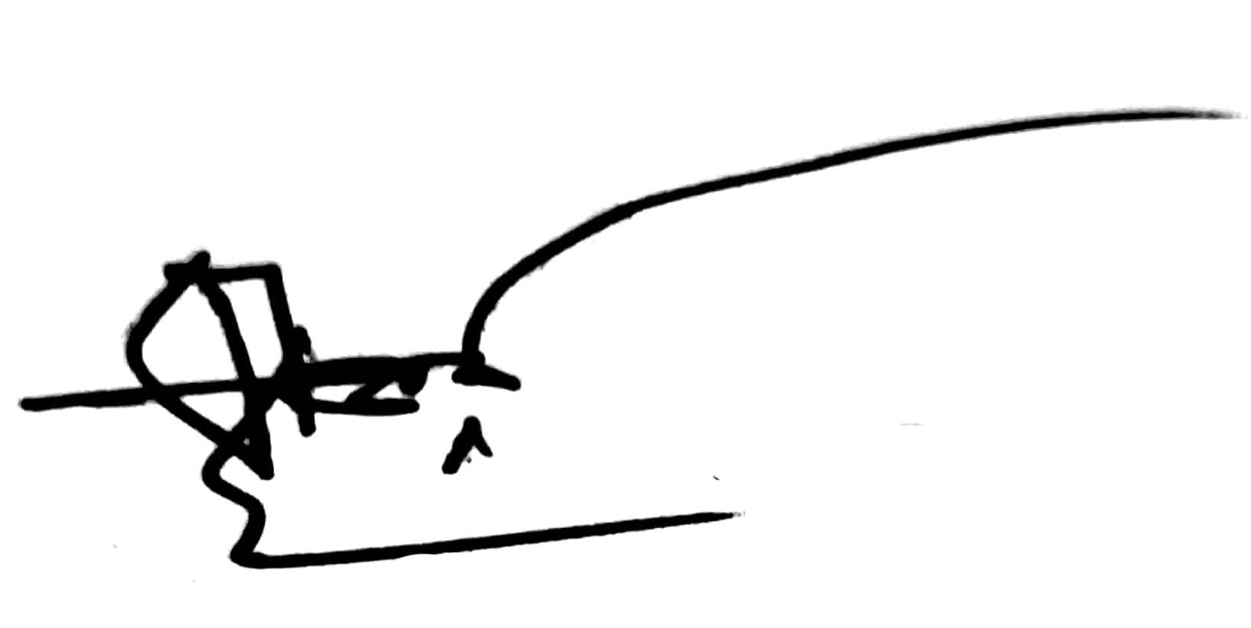
Copy to:
1. Director, RpMCH
2. Registrar/Asst.Registrar/IMO MU-I/II/III/IV/V/VI
3. Notice board
4. Office copy

Prof. Dr. Md. Mahfuzer Rahman
Professor & Head
Department of Medicine
Rangpur Medical College & Hospital

